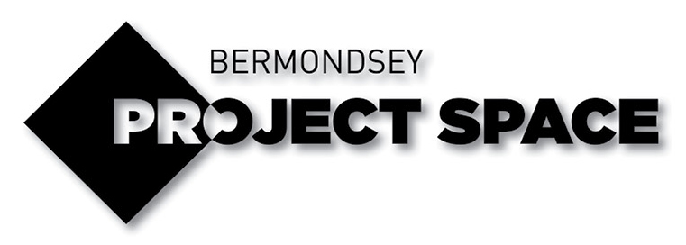

APPLICATION FORM

MY EXHIBITION
26 - 30th July 2022
Application Deadline 27th June

My Exhibition is an opportunity to learn from professional artists and show your artwork in a central London art gallery.

Working with engaging local artists, you will also be able to take part in practical workshops such as:
- Painting
- Photography
- Filmmaking
- Spoken word
- Zine-making

There will also be advice sessions on higher education and arts careers from industry experts. In addition, you will have the opportunity to meet new people and become part of a network of creative young people.

The week will end with a group exhibition of your art, which will be open to friends, family and the public.

TO APPLY
Please complete the following:

- Complete the short form below
- Complete the monitoring form below
- Select two images/videos of artworks you’ve made that you’re most proud of
- Email the completed form and images to:
abps@project-space.london

NAME:

AGE:

SCHOOL/COLLEGE:

Why do you want to take part in the My Exhibition project?

Please explain why you would like to be involved in this project.

You could write about your future ambitions, what skills you would like to learn, or what you would like to get out of the opportunity.

Please answer in no more than 100 words. Feel free to use bullet points.

Your answer:

What inspires you?

Please write about something / someone creative that you find inspiring

This could be a painting, film, song, book, musician, artist or filmmaker.

Why do you like it, how does it make you feel?

Please answer in no more than 100 words. Feel free to use bullet points.

Your answer:

What do you like to make?

Please tell us a little about what kind of art you like to make, and what themes you are interested in.

You could tell us about a song you wrote about your family, a photograph you took of somewhere you visited, or a drawing you made of where you live, for example.

Please answer in no more than 100 words. Feel free to use bullet points.

Your answer:

EQUALITY MONITORING FORM

Thank you for making an application to My Exhibition

What is this form?

BPS is committed to supporting diversity in the arts. Therefore information is captured on the demographic of applicants, to help to assess if we’re achieving our aims.

If there are any questions you would prefer not to answer, please leave that section blank.

How would you describe your ethnic origin?

Your answer:

Do you consider yourself to have a disability?

YES NO (Delete as appropriate)

If ‘yes’, please let us know of any access requirements:

Do you identify as part of the LGBTQIA+ community?

YES NO (Delete as appropriate)

If ‘yes’, please describe:

What does the main income earner in your household do for a living?

- Clerical and intermediate occupations e.g., Secretary, nursery nurse, office clerk, call centre agent
- Middle or junior managers e.g., office manager, warehouse manager, restaurant manager
- Modern professional occupations e.g., teacher, nurse, social worker, artist, musician, software designer
- Routine manual and service occupations e.g., van driver, cleaner, porter, waiting staff, bar staff
- Semi-routine manual and service occupations e.g., postal worker, security guard, receptionist
- Senior managers and administrators e.g., finance manager, chief executive
- Technical and craft occupations e.g., fitter, plumber, printer, electrician
- Traditional professional occupations e.g., accountant, solicitor, scientist, medical practitioner
- Unemployed/never worked/long term sickness

